SIMATSENGINEERING(SAVEETHASCHOOLOFENGINEERING)
DepartmentofComputerScienceandEngineering

ASSESSMENTTOOL2–ConceptMapping

CourseCode: | CSA0305 | CourseTitle: |  | DataStructures
COAssessed: | CO1–Imitation(BL3,BL4) | Assessment: |  | AssessmentTool2–Concept Mapping
Weightage: | 35%ofCIA | TotalMarks: |  | 100
CO1Statement: | ApplysuitabledatastructuresandADTsforefficientproblemsolvingbyanalyzingtimeandspace complexity.
Student Name: | M.VAISHNAV |  | Reg. No.: | 192524251
Section/Batch: |  |  | Date: | 10/07/2026
CodeofConduct
I M.VAISHNAVcertify that this submission is my original work and that I have adhered to the guidelines specified for this assessment. I understand that any violation of academic integrity rules will result in disciplinary action.
Signature of the Student: M.VAISHNAV (192524251)
Instructions
- Thistestcontains5Conceptmappingquestions.Total:100Marks.
- Whenastudentanswerusingaconceptmap,inevaluationtheanswershouldbewithfollowingfour requirements: Understanding of concepts, Connections between ideas, Logical structure, Clarity of representation.
- Nonegativemarking.Unansweredquestionscarryzeromarks.

Section/Topic | Focus | QNos | Marks
Linkeddata structure | Basicdata structure | 1 | 20
PrimitiveandNon-PrimitiveDataStructure-Linear and Non-Linear Data Structure | ClassificationsofLineardatastructure | 2 | 20
SearchData Structure | LinearSearchandBinary Search | 3 | 20
Recursion,Performance analysis | Recursion | 4 | 20
TreeData Structures | ClassificationsofTreedatastructure | 5 | 20
GRANDTOTAL: |  | 100Marks

AnnexureA–ConceptMapping

- A student attendance system records daily presence data. Construct a concept map linking Array → Fixed Size → Sequential Access → Linked List → Dynamic Allocation → Flexibility. Explain how each structure works and justify which is more suitable for dynamic data updates. (20 Marks)
- A weather monitoring system collects temperature, humidity, and wind data continuously. ConstructaconceptmaplinkingPrimitiveDataTypes→Non-PrimitiveStructures→Linear Structures→Non-LinearStructures→Applications.Includeexamplesandexplainhoweach structure supports continuous data processing. (20 Marks)
- Adigitalarchivestoresmillionsofdocuments.ConstructaconceptmaplinkingSearching→ Linear Search → Binary Search → Sorted Data → Time Complexity → Performance. Analyze the impact of data organization on search efficiency and justify the best technique.
(20 Marks)
- Aprogramprocessesnestedexpressionsusingrecursionandmayencounterdeepnesting.
ConstructaconceptmaplinkingRecursion→CallStack→StackOverflow→ErrorHandling
→Efficiency.Analyzepotentialissuesandjustifystrategiestohandlethem.(20Marks)
- A company maintains hierarchical employee records with multiple levels of management. Construct a concept map connecting Tree → Nodes → Levels → Traversal (DFS/BFS) → Searching→Efficiency.Analyzehowtraversaltechniquesaffectperformanceandjustifythe most suitable approach for retrieving employee data. (20 Marks)
RubricsforCalculation
Criteria | Weightage | Level4–Exemplary | Level 3 – Proficient | Level 2 – Developing | Level 1 – Beginning
Understandingof  ProblemContext | 20 | Clearlyunderstandstheproblemandaccuratelyidentifiesallrequirements | Goodunderstandingwithminorgaps | Basicunderstanding;somerequirementsunclear | Poorunderstandingormisinterpretationof the problem
ApplicationofConcepts | 30 | Accuratelyappliesappropriateconcepts to solvecomplexproblems | Appliesrelevantconceptscorrectlywithminorerrors | Appliesbasicconceptswithlimitedaccuracy | Failstoapplyappropriateconcepts
Problem-SolvingApproach | 20 | Logical,well-structured,andefficientapproach | Mostlylogicalapproachwithminorgaps | Basicapproachwithsomeinconsistencies | Illogicalorunclearapproach
AccuracyofSolution | 20 | Completelycorrectsolutionwithproperjustification | Mostlycorrectwithminorerrors | Partiallycorrectsolution | Incorrectorincompletesolution
Clarity | 10 | Clear,well-organized,andproperlyexplainedsolution | Understandablewithminorclarityissues | Limitedclarityandexplanation | Poorlypresentedand difficult tounderstand

FacultyIn-charge | CourseCoordinator | ProgramDirector
Signature: | Signature: | Signature:
Date: | Date: | Date:

══════════════════════════════════════════════════════════════════
Q1. STUDENT ATTENDANCE SYSTEM – RAILWAY TRACK CONCEPT MAP
══════════════════════════════════════════════════════════════════

STUDENT ATTENDANCE SYSTEM
│
────────────────────────────────────────────────────────────────
ARRAY TRACK LINKED LIST TRACK
────────────────────────────────────────────────────────────────

Fixed Size Dynamic Allocation
│ │
▼ ▼
Sequential Access Flexible Memory Usage
│ │
▼ ▼
Fast Direct Access Easy Insert / Delete
│ │
└──────── Comparison ──────────┘
│
▼
Dynamic Data Updates
│
▼
LINKED LIST IS BETTER

Explanation:
• Array stores data in contiguous memory locations.
• Array size cannot be changed after creation.
• Linked List stores data dynamically using nodes.
• Linked List allows insertion and deletion easily.
• Attendance records change frequently.
• Therefore, Linked List is more suitable for dynamic updates.

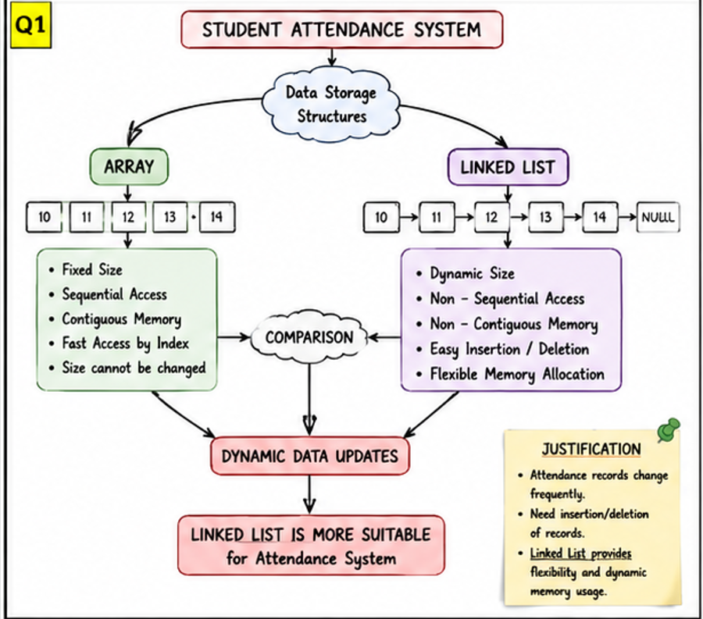

Linked Data Structure – Student Attendance System

Understanding of Concepts
- Arrays store elements in contiguous memory locations.
- Linked Lists store data using nodes connected through links.
- Both are linear data structures used for data storage.

Connections Between Ideas
- Attendance records need frequent insertion and deletion.
- Arrays provide fast access but fixed size.
- Linked Lists provide dynamic memory allocation and flexibility.

Logical Structure & Justification
- Compare Array and Linked List features.
- Analyze their advantages and limitations.
- Conclude that Linked List is more suitable for attendance management because records change frequently.

Clarity of Representation
- Railway-track concept map clearly separates both structures.
- Arrows show comparison and decision-making process.
- Key features are easy to understand visually.

══════════════════════════════════════════════════════════════════
Q2. WEATHER MONITORING SYSTEM – TREE CONCEPT MAP
══════════════════════════════════════════════════════════════════

WEATHER MONITORING SYSTEM
│
┌──────────────┴──────────────┐
│ │
▼ ▼
Primitive Data Types Non-Primitive Structures
(int, float, char) (Array, Linked List)
│ │
└──────────────┬──────────────┘
│
▼
Data Organization
│
┌─────────────────┴─────────────────┐
│ │
▼ ▼
Linear Structures Non-Linear Structures
(Array, Linked List) (Tree, Graph)
│ │
▼ ▼
Continuous Sensor Logs Weather Prediction Models
│ │
└─────────────────┬─────────────────┘
▼
Applications

Explanation:
• Primitive types store temperature, humidity, and wind speed.
• Arrays and Linked Lists store continuous sensor readings.
• Trees and Graphs help in complex weather analysis.
• Linear structures process sequential data efficiently.
• Non-linear structures support advanced forecasting systems.

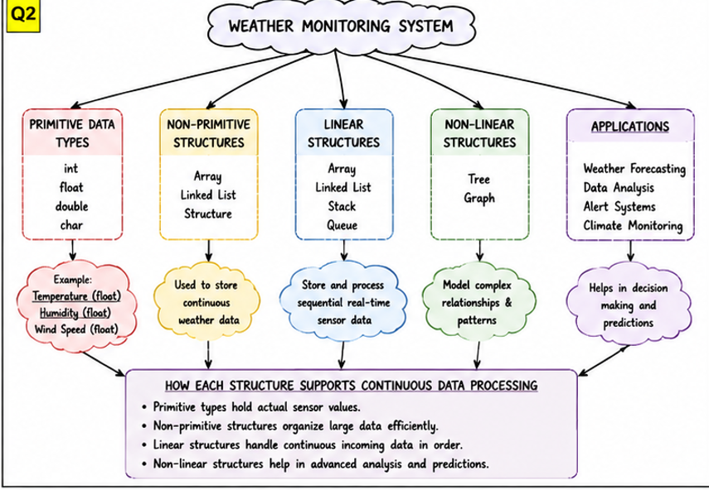

Primitive and Non-Primitive Data Structure – Weather Monitoring System

Understanding of Concepts
- Primitive data types include int, float, char, and double.
- Non-primitive structures include arrays, linked lists, trees, and graphs.
- Data structures help organize weather information efficiently.

Connections Between Ideas
- Primitive types store sensor values such as temperature and humidity.
- Linear structures manage sequential weather data.
- Non-linear structures support prediction and analysis.

Logical Structure & Justification
- Start with data classification.
- Connect primitive and non-primitive structures.
- Show how each structure contributes to weather monitoring and forecasting.

Clarity of Representation
- Tree-style concept map clearly displays hierarchy.
- Branches indicate relationships among structures.
- Easy visualization of data classification.

══════════════════════════════════════════════════════════════════
Q3. DIGITAL ARCHIVE – PERFORMANCE PYRAMID CONCEPT MAP
══════════════════════════════════════════════════════════════════

PERFORMANCE
▲
│
Time Complexity
▲
┌───────────┴───────────┐
│ │
▼ ▼
Binary Search Linear Search
O(log n) O(n)
▲
│
Sorted Data
▲
│
Searching
▲
│
Digital Archive

Explanation:
• Linear Search checks every document one by one.
• Binary Search divides data into halves repeatedly.
• Binary Search requires sorted data.
• Time complexity of Linear Search is O(n).
• Time complexity of Binary Search is O(log n).
• Binary Search is the best choice for millions of documents.
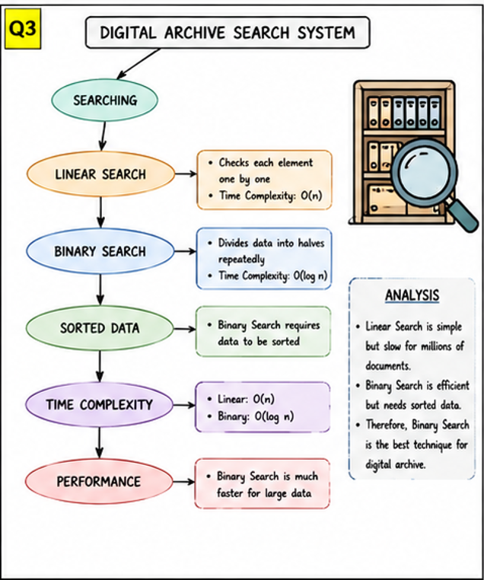

Search Data Structure – Digital Archive Search

Understanding of Concepts
- Searching helps locate records efficiently.
- Linear Search examines elements one by one.
- Binary Search repeatedly divides sorted data.

Connections Between Ideas
- Binary Search requires sorted data.
- Time complexity influences performance.
- Faster search methods improve archive retrieval efficiency.

Logical Structure & Justification
- Compare Linear Search and Binary Search.
- Analyze time complexity O(n) and O(log n).
- Justify Binary Search as the best option for large digital archives.

Clarity of Representation
- Pyramid structure emphasizes performance comparison.
- Information flows from searching to efficiency.
- Visual hierarchy makes concepts easy to follow.

══════════════════════════════════════════════════════════════════
Q4. RECURSION – WATERFALL CONCEPT MAP
══════════════════════════════════════════════════════════════════

RECURSION
│
▼
Function Calls
│
▼
Call Stack
│
▼
Deep Nesting?
│
┌──────────┴──────────┐
│ │
Yes No
│ │
▼ ▼
Stack Overflow Normal Execution
│
▼
Error Handling
(Limits, Try-Catch Blocks)
│
▼
Efficiency
│
▼
Optimized Recursive Logic

Explanation:
• Recursion solves problems by calling itself.
• Every recursive call occupies stack memory.
• Excessive recursion can cause stack overflow.
• Error handling prevents program crashes.
• Tail recursion and iteration improve efficiency.
• Limiting recursion depth avoids overflow.
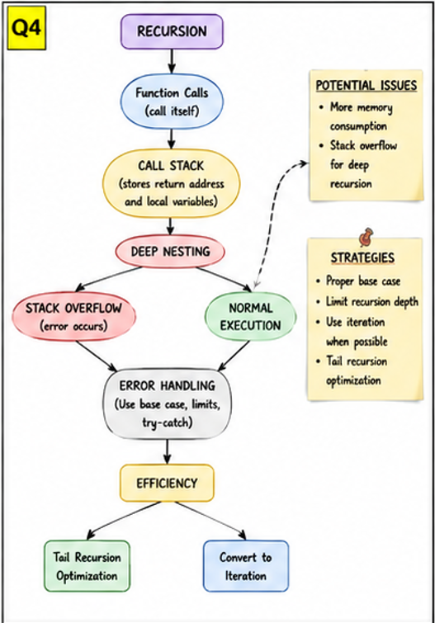

Recursion and Performance Analysis

Understanding of Concepts
- Recursion is a technique where a function calls itself.
- Recursive calls use stack memory.
- Excessive recursion may cause stack overflow.

Connections Between Ideas
- Function calls create a call stack.
- Deep recursion increases memory usage.
- Error handling and optimization improve performance.

Logical Structure & Justification
- Begin with recursion process.
- Show problems such as stack overflow.
- Present solutions like tail recursion and iteration.

Clarity of Representation
- Waterfall concept map shows step-by-step execution.
- Cause-and-effect relationships are clearly visible.
- Easy to understand recursion flow.

══════════════════════════════════════════════════════════════════
Q5. EMPLOYEE MANAGEMENT SYSTEM – ORGANIZATION CHART CONCEPT MAP
══════════════════════════════════════════════════════════════════

COMPANY TREE
│
▼
CEO
│
┌───────────────────┼───────────────────┐
│ │ │
▼ ▼ ▼
Manager A Manager B Manager C
│ │ │
▼ ▼ ▼
Employees Employees Employees

│
▼
Nodes
│
▼
Levels
│
┌───────────────┴───────────────┐
│ │
▼ ▼
DFS BFS
(Depth First Search) (Breadth First Search)
│ │
└───────────────┬───────────────┘
▼
Searching
│
▼
Efficiency

Explanation:
• Employee hierarchy is represented using a Tree.
• Each employee is a node.
• Management layers form levels.
• DFS explores one branch completely before moving.
• BFS explores level by level.
• BFS is best for retrieving employee information level-wise.

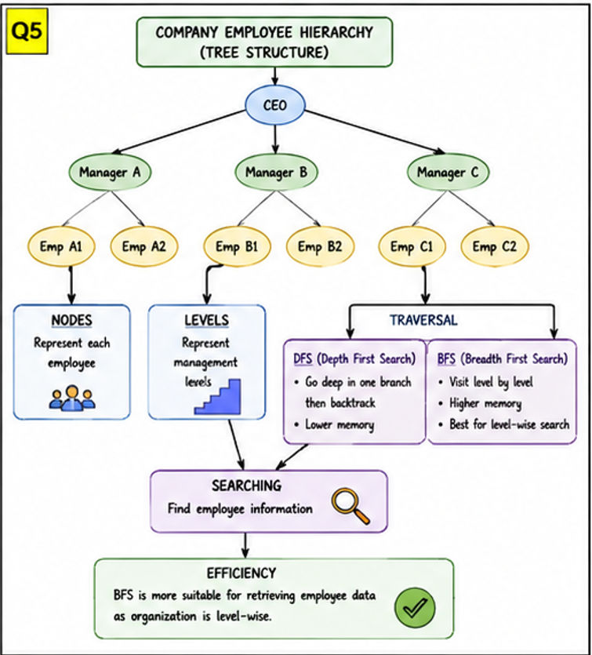

Tree Data Structure – Employee Hierarchy

Understanding of Concepts
- Trees are non-linear hierarchical data structures.
- Nodes represent employees.
- Levels represent management hierarchy.

Connections Between Ideas
- CEO acts as the root node.
- Managers and employees form branches.
- DFS and BFS are traversal methods used for searching.

Logical Structure & Justification
- Represent organization as a tree.
- Compare DFS and BFS traversal techniques.
- Conclude BFS is more suitable for level-wise employee retrieval.

Clarity of Representation
- Organization-chart layout resembles real company hierarchy.
- Nodes and levels are clearly identified.
- Traversal methods are easy to compare visually.

